Pre-Treatment Booklet

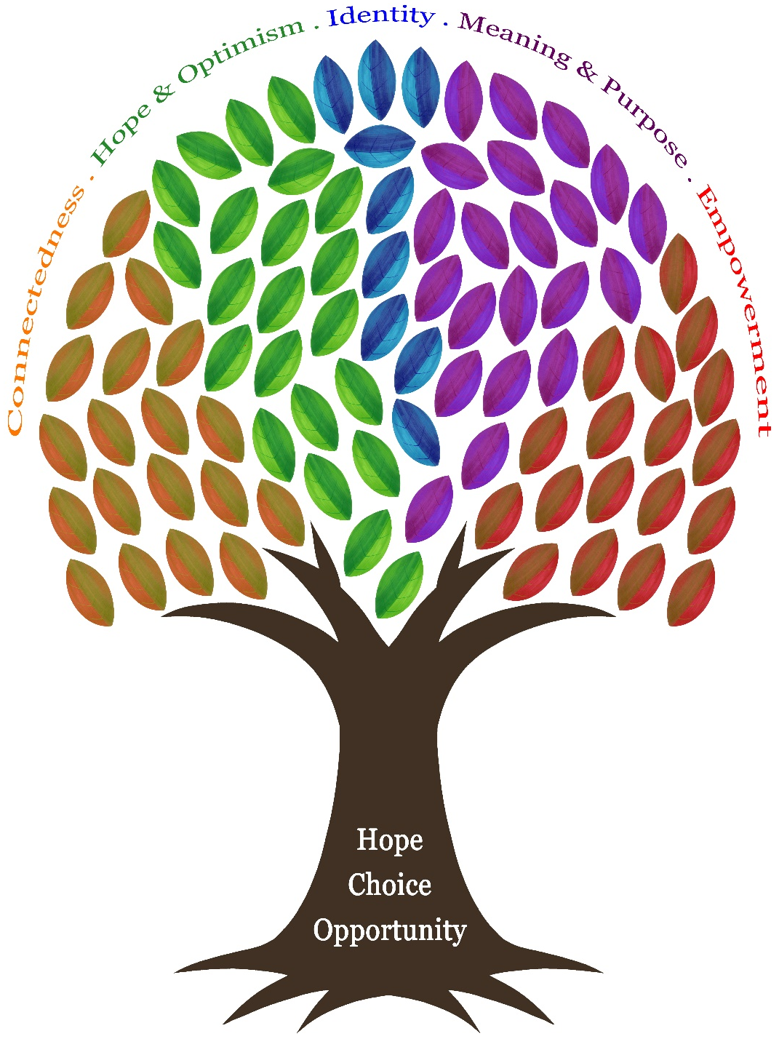

The Wellbeing Team
Quayside House, Rounds Green Road, Oldbury,
West Midlands, B69 2DG.

Tel: 0121 543 4292 / 0121 543 4295
Contents

- Preparing Yourself for Therapy
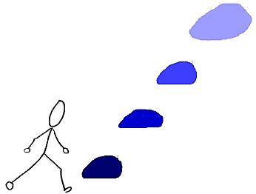
- Setting Goals
AIM
- The Window of Tolerance
- Getting Active and Moving
- Slowing Down
- Sleep
- Eating
- Contact Details

Try not to be too overwhelmed by this booklet … we know there is a lot in here but just try your best to pick one thing to start with and see how you go from there.
However, we do expect you to have had a look at some of the ideas in here and to have started working on at least one of them before seeing us.
If you have trouble with anything please call us on 0121 543 4292 and ask to speak to someone from the Wellbeing Team.

We hope you find this helpful and good luck!
- Preparing Yourself for Therapy

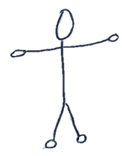


There is hope: recovery starts with you! Having a willingness and determination to engage and being motivated to make positive changes in life will help you to move forward.
Some of the information in this booklet may seem trivial, but the things covered are the basics of good mental health. Increasing your self-care now whilst you wait for treatment can increase positive outcomes from therapy. It will help you to have a more solid base from which to start as therapy isn’t an easy journey; it will come with its ups and downs.

Reading through and filling in this booklet should help you make positive steps towards your recovery.

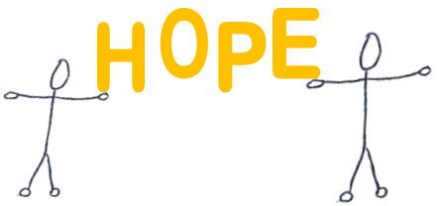

- Setting Goals
Setting a SMART Goal … SMART stands for:
Specific
Measurable
Achievable
Relevant
Time Limited

It is hard to move forward if we don’t know where to start or where we want to get to! We need to identify small manageable goals so we can work towards success and build confidence. This will help with your motivation and self-confidence.
Goals can be either short-term, medium-term or long-term.
- Short-term goals may be achievable within a matter of weeks – starting with these goals will help make your journey to recovery more manageable.
- Long-term goals may take years to reach and often involve changing habits of a lifetime.
Once you have created your goals, the journey to recover begins and it is up to you to practice and take smalls steps to get closer to your goal.
- I would like to feel less anxious.
- I would like to stop avoiding things.
- I would like to do the things I used to do.
Goals which are NOT SMART

Examples of SMART Goals
- I would like to meet a friend for a drink 3 times a week and spend 30 minutes talking to them. I would like to achieve this within the next 3 months.
- Whilst I am looking for a job, I would like to call 3 prospective employers each week and ask them about any vacancies. I would like to be able to do this within the next 3 weeks.
- Instead of worrying about things all day, I would like to allocate 20 minutes a day writing down all my worries and try to manage them. I would like to achieve this by the end of the month.
Identify what needs to change for you to feel better
Specific
Measurable
Achievable
Relevant
Time Limited
Try to ask yourself the following questions …
What do you hope to gain from therapy?
What do you hope to have achieved?
What will be different for you?

Spend some time thinking about your individual goals and write these down. Remember to make these goals as SMART as possible. This may not be something you can do straight away; it may take a little time to work out what is most important for you to change.

My Goals:
.............................................................................................................................................................................................................................................................................................................................................................................................................................................................................................................................................................................................................................................................................................................................................................................................................................................................................................................................................................................................................................................................................................................................................................................................................................................................................................................................................................................................................................................................................................................................................
If you are not sure what your goals are yet, then that’s okay, but have a think as you read this booklet to see what would be helpful to start with.
- The Window of Tolerance
When we experience trauma our senses are heightened, our experiences and reactions are intensified and we are less able to access the appropriate skills to function well. Because of this we operate outside of something called the window of tolerance.

When we are within our window of tolerance we are in our most calm state; we can manage our emotions and are able to calm ourselves down. Outside of this window we can be hyper-aroused or hypo-aroused.
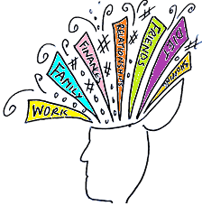



Hyper-arousal is when we have excess energy which is often displayed as anxiety, hypervigilance, emotional flooding etc. In this state we are unable to relax so find it difficult to sleep, eat and manage emotions.

Hypo-arousal occurs when we have too much going on and leads to us shutting down. In this state we may be exhausted, depressed, numb, disconnected, etc. this will impact on our appetite and mood.

Being able to understand when you are in each of these states will help you know how to respond and shift out of them. We can’t be in these states forever and the sooner we identify them, the sooner we can do something to change them.
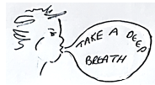
If you are hyper-aroused, try to slow things down through deep breathing, use the excess energy by exercising or listen to soothing music.

If you are hypo-aroused, try to get moving and do something that stimulates your senses, for example: go for a walk, smell essential oils, dance.






HEARING
TOUCH
SIGHT
TASTE
SMELL

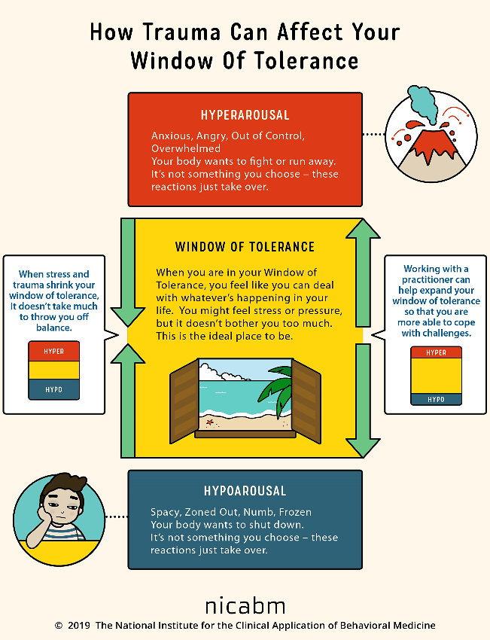
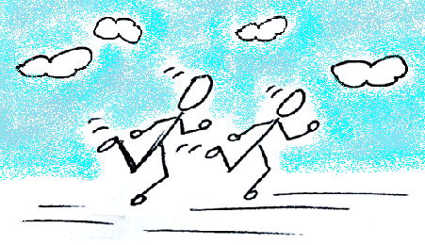
- Getting Moving and Active

If you’re feeling too slow, get moving…

Getting Started
Getting started can be really difficult, any negative thoughts make you feel down and discouraged, which means you feel slowed down and tired and less inclined to be active.
Your activity level goes down; you start to avoid situations, which means that you don’t have positive thoughts and experiences; your confidence is further reduced which increases the negative thoughts and low mood and so on.
Low mood ‘what’s the point?’

Do less, avoid things

Feel worse, discouraged, inadequate, guilty …

Do even less

When our mood sinks and activity levels lower, this can also lead to:
- Negative thoughts
- Lack of confidence
- Even less energy
- Harder to communicate
- Suicidal thoughts

But there is a way out! Becoming a little more active again is one way of breaking this vicious spiral.

Why Become More Active?
- Activity makes us feel less tired – normally when you feel tired you need a rest but when you are feeling low the opposite is true- you need to do more. Doing nothing makes you feel more exhausted and lethargic.

- Activity distracts us – being active gives your mind something different to think about instead of dwelling on your worrying negative thoughts when you are inactive.

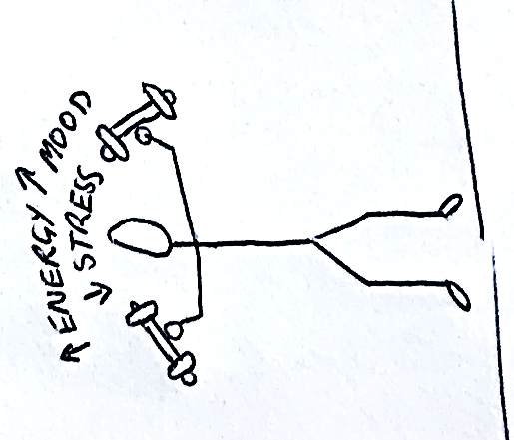
- Activity improves our confidence – being active gives you more of a sense that you are taking control of your life again and achieving something worthwhile. Small steps help rebuild shattered confidence, and then there is a chain reaction effect where you feel motivated to try to achieve something else.

- Activity improves our thinking – activity improves our thinking and memory and helps us to get a more realistic perspective on things.

- Activity can involve others – being more involved with people improves your chances of feeling better.

Start by writing a list of things that you know you used to enjoy or used to enjoy doing.
Tips:
- Try to include activities that make you happy and give you pleasure, such as gardening, calling a friend, having a bath, listening to music.
- If you experience no pleasure, start with things that give you a sense of achievement; for example, making yourself a cup of tea, ironing, food shopping.
Some activities will fit into both the categories of pleasure and achievement.

Here are Some Ideas:
Go Outdoors
- Gardening
- Walking
- Visiting
- Barbecues
- Travelling
- Camping
- Scouting
- Bird watching
- Hunting
- Fishing

Keep Busy In the House
- Radio
- Listen to music (pop, classical etc.)
- Movies
- Reading
- Housework (cleaning, laundry)
- Television
- Home decorating
Be Creative
- Sewing/needle work
- Writing
- Pottery
- Singing
- Handicrafts
- Hairstyling
- Cooking/baking
- Leatherwork
- Painting/drawing

Get Out of the House
- Church activities
- Repair work (i.e. cars, home)
- Holiday activities
- Pets/livestock
- Parties
- Concerts
- Clubs/lodge
- Clothes
- Attending plays
- Dating
- Auto-racing
- Wood working
- Driving
- Childcare
- Collecting
- Shopping
Education
- Foreign languages
- Speeches/lectures
- Politics
- History
- Science
- Photography
Be Active
- Dancing
- Golf
- Football
- Swimming
- Bowling
- Wrestling
- Cycling
- Exercise
- Tennis
- Basketball

Play Games
- Playing card
- Puzzles
- Checkers/chess
- Model building
- Table games
- Pool

My Activity List:
...............................................................................................................................
...............................................................................................................................
...............................................................................................................................
...............................................................................................................................
...............................................................................................................................
...............................................................................................................................
...............................................................................................................................
It can be easy to become tied up in chores that have to be done and never get the chance to do something that you want to do.
Pick at least ONE activity to give you a sense of pleasure and ONE activity to give you a sense of achievement.
Tips:
- Do not expect too much too soon, pace yourself and choose small goals
- Reward yourself
- Try to remind yourself – I can try and that nothing is lost by trying
- Remember the five-minute rule!

The Five-Minute Rule:
- We often think that we feel motivated before we start an activity of any kind, and that motivation keeps us going. What happens in most cases is the activity comes first, and after about 5 minutes in the activity your motivation levels will rise.
- So give yourself just 5 minutes – try out the activity and see if your motivation levels rise.

Remember:

You’re doing this to help yourself feel better. It’s hard to get started with these things, but once you do it will get easier.

If something does not work out for you, then try something else!

Try spending some time every day doing something you like doing.

Tackling Blocks
When we’re trying to make a change in our lives, it is easy for us to find reasons to stay how we are rather than moving forward. It is important to be aware of what may get in our way so we can tackle these issues.
Think about the blocks you may experience when trying to do these activities.
For example, thoughts like:
“What’s the point?”
“Where’s the use?” “I can’t do that”

Feeling too tired, or lacking in energy.

Now to decide when would be best to carry out the activities on your activity list …

Think about the time of day where you will be less distracted perhaps, or will have more energy.

Use the schedule on the next page to help you make a plan.
Activity Schedule

Setting yourself a schedule can help you to plan and stick to activities you want to do.

TIME | Monday | Tuesday | Wednesday | Thursday | Friday | Saturday | Sunday
9am-10am
10am-11am
11am-12pm
12pm-1pm
1pm-2pm
2pm-3pm
3pm-4pm
4pm-5pm
5pm-6pm
6pm-7pm
7pm-8pm
8pm-9pm
9pm-10pm
10pm-11pm

Exercise

Exercise is helpful if you’re hyper-aroused to release some of the difficult feelings you are experiencing or you are feeling hypo-aroused and need to feel more and get moving.

Benefits of Exercise
Many health benefits can be had from participating in just 30 minutes of moderate intensity exercise for 3 days a week.
Exercise causes chemical changes in our brains which can help to positively effect on not only our physical health but our moods.
Mental Benefits
- Reduced anxiety, depression and negative mood symptoms.
- Improved self-esteem and cognitive function.
- Stress relief.
- Boost of mental and physical energy.
- Occupying your mind positively.
Physical Benefits
- Weight control.
- Increased cardiovascular fitness levels and exercise tolerance.
- Reduced blood pressure levels.
- Increased perceived energy levels.
- Increased upper body and hand grip strength levels.
- Improved sleep.

Tips to Exercise More:
- Find exercise activities you enjoy – for example you could try: group fitness classes, swimming, running around the park.
- Walk instead of driving/taking public transport.
- Find a workout buddy.
- Choose the stairs over lifts.
- Start off small! Fit in a 10 minute workout when you can.
Keeping Track of Your Exercise
You could start by setting yourself the challenge of fitting in a 10 minute brisk walk 3 times a week. This may not be realistic for you so maybe try to walk in your garden for a little while.
Start off with small changes and eventually you’ll be able to increase the duration and intensity of your exercise. Over time you should notice a difference in how you feel and should hopefully see physical improvements too.
Try using this table, or create your own to keep track of the exercise you’re doing and importantly, how you feel afterwards.

Week 1
Day of the Week | Type of Exercise | Duration | How you Felt
Monday

Tuesday

Wednesday

Thursday

Friday

Saturday

Sunday

- Slowing Down

If you’re feeling too much and have gone out of the top of your window of tolerance then you need to slow down. Here are some tips that can help and the more you practice these skills every day the more effective they will be.

A Self-Soothe Box

A self-soothe box can be created to help you through times when you feel overwhelmed by emotion or if you have the urge to harm yourself.

It can be filled with memories or objects to help soothe your senses, to keep you happy and calm and feel more able to get through the feelings.

On YouTube type into the search bar: “How To: Make a Self Soothe Box” and find out more about this.


Touch: using fabrics such as silk and velvet, soft woolly socks or blanket, teddy bear, comforter or grounding object, hand or foot lotion, massage oils, nail varnish, make-up.
TOUCH

SIGHT
Sight: having a photo album, watching you favourite DVD, reading your favourite book or magazine, a picture of your safe place or a place that brings you comfort, self-soothe statements.

HEARING
Hearing: soothing or inspiring music, listening to your favourite music, a reminder of phone numbers to ring.

TASTE
Taste: fruity snack or treat, coffee, your favourite biscuits.


SMELL
Smell: Oils, perfume, coffee, flowers.
My Self-Soothe Box

Think about what you may want to be in your box and try to start creating this at home. Try to notice and focus on the 5 senses! 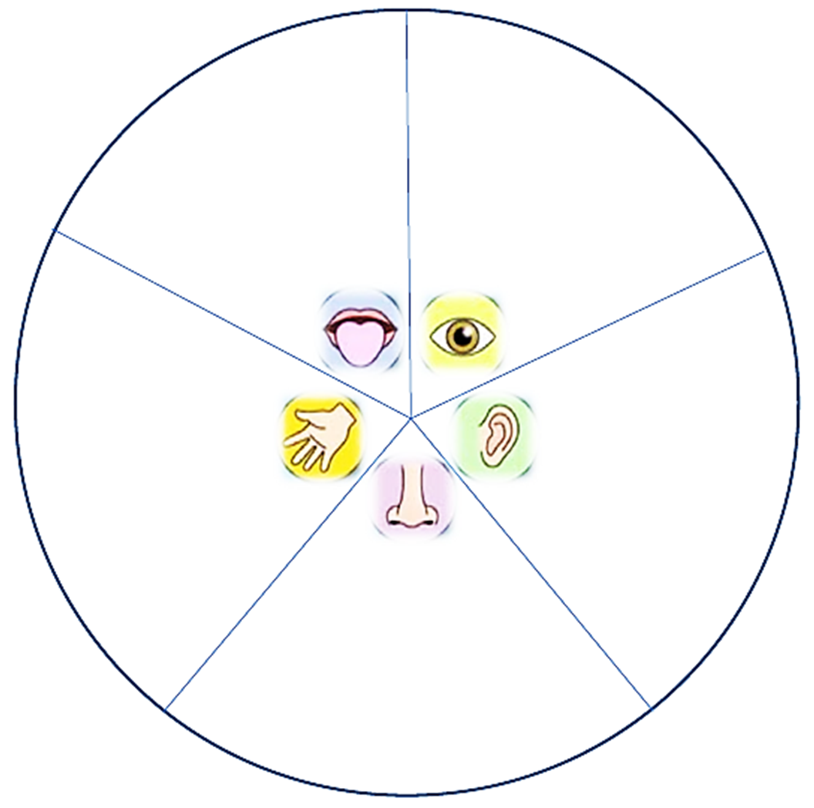

Remember to tell yourself: “I can use these things to help me feel soothed or calmer at times I feel distressed”
Deep Breathing

Deep breathing is a relaxation technique performed by taking slow, deep breaths. When practiced regularly, deep breathing provides immediate and long-term relief from stress and anxiety.

How Deep Breathing Works
During periods of anxiety, the body triggers a set of symptoms called the stress response. Breathing becomes shallow and rapid, heart rate increases, and muscles become tense. In opposition to the stress response is the relaxation response. Breathing becomes deeper and slower, and the symptoms of anxiety fade away. Deep breathing triggers this response.
- Inhale. Breathe in slowly through your nose for 4 seconds.
- Pause. Hold the air in your lungs for 4 seconds.
- Exhale. Breathe out slowly through your mouth for 6 seconds.
Tip: Pucker your lips, as if you are blowing through a straw, to slow your exhalation.
- Repeat. Practice for at least 2 minutes, but preferably 5 to 10 minutes.
Tips:
- Slow down! The most common mistake is breathing too fast so take your time and count slowly.
- Counting each breath will help keep your mind of the source of your anxiety, if your mind wanders return your focus to counting.
- Lengthen or decrease the time your breath so that you feel comfortable.
- Put your hands on your stomach to feel the rise and fall. You must try not to breathe from your chest as this is shallow breathing and can worsen anxious feelings.

Mindfulness
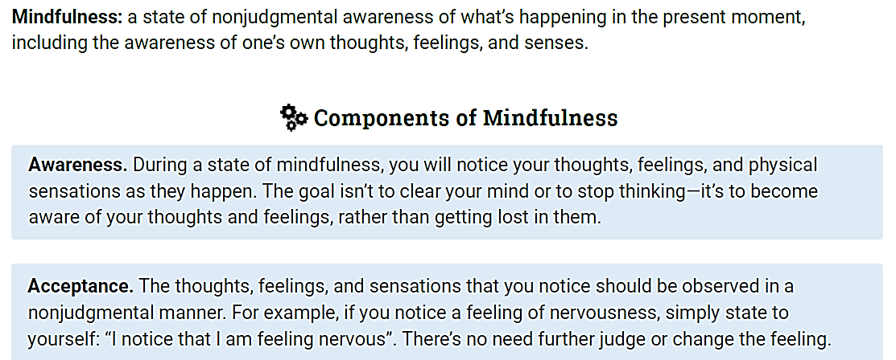

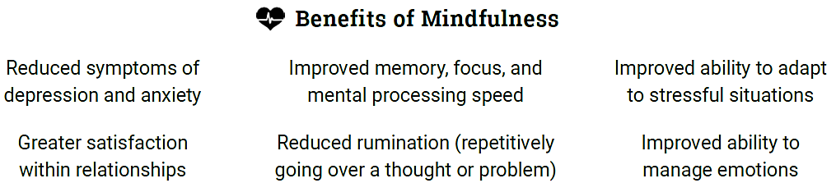
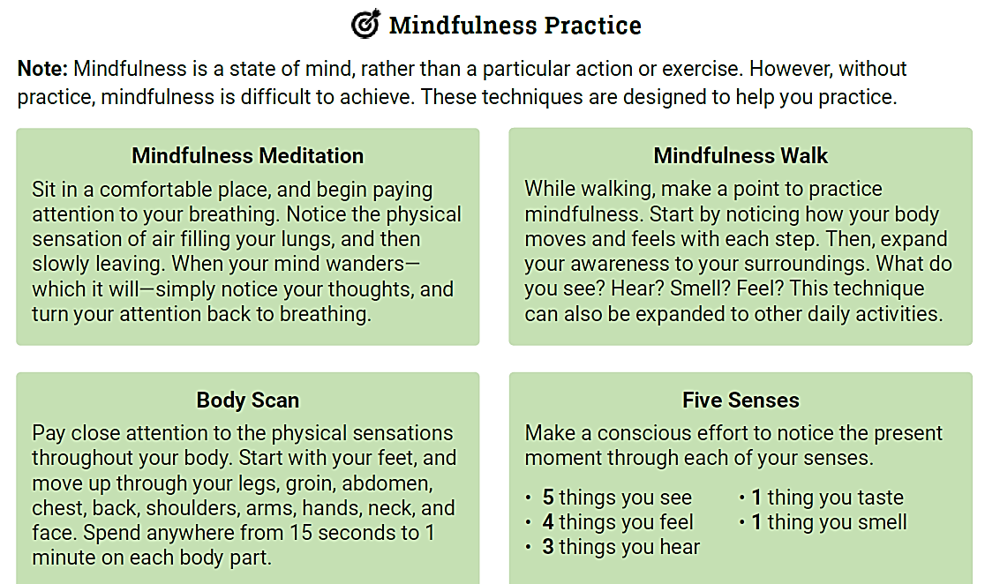
Mindful Colouring

You may want to try colouring as a way to de-stress, relax and distract yourself from any worries. This is another skill that can help you to feel calmer if you have got out of your window of tolerance.
Try colouring in this picture below or have a look online or in the shops for other adult colouring books …

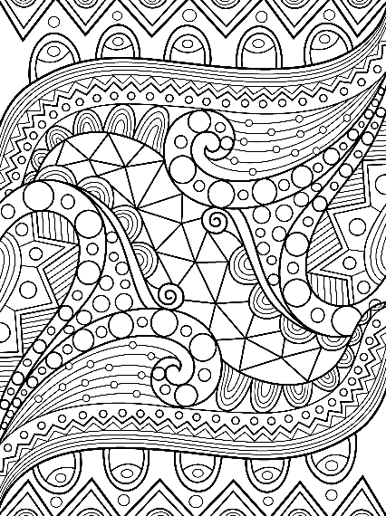

Positive Emotions can be Difficult
Gilbert, 2010.
Sometimes people can be fearful of positive emotions, as they feel they are moving into unfamiliar ground or letting themselves off the hook. When you’ve felt worried and angry for a long time, positive feelings may not seem a part of you or real.
It can take a while to get used to what positive feelings feel like, and we can even be worried and scared of them at times. When we work on compassion and feelings of kindness they can make us feel vulnerable or weak.
Some individuals, understandably, have learnt not to allow themselves to feel positive emotions. The problem is that our brain’s positive emotion systems don’t get any exercise, but we can start exercising them to get them working again!
So, rather than assuming positive emotions are not for us, we can recognize why we are fearful of them and this can allow us to focus on positive moments such as enjoying someone’s company or having a cup of coffee.
Our minds can react quickly to certain situations due to our early experiences and the ways we have learnt to protect ourselves – and this is not our fault.
So What Can We Do?
- With practise, we can learn to step back, stop and think differently before we act on our initial reactions. Learning to stop, notice and pay attention to what is going on in our mind and body – mindfulness – is one of the first steps to having more control.
- We must learn how to be compassionate towards our feelings, rather than avoiding them or fighting with them.
- When we feel kindness or affection from others whilst we feel overwhelmed or distressed we can feel soothed. When we feel soothed, these feelings help us feel safer and endorphins (substances in our brain) are released – these are important for our well-being.

Remember:
We are often a lot harder on ourselves than we are to other people, so take note of how you are speaking to yourself and try to be kinder to yourself. Like anything this will take time and you will need to start gradually.
  Be Kind to Yourself  Positive Steps to Wellbeing  We all have bad days, but we must choose to be kind to ourselves. Treat yourself how you would treat a friend in the same situation. | Exercise Regularly  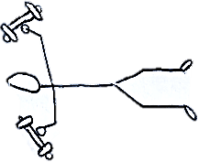  Physical activity helps lift our mood, reduces stress and anxiety, improves physical health, and gives us more energy. So, find something you enjoy and do it.
Take up a Hobby or Learn a New Skill  Increase your confidence and interest, meet others, or prepare for finding work. | 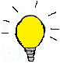  Have some Fun/Be Creative  Having fun or being creative helps us feel better and increase our confidence. Enjoy yourself!
Help Others  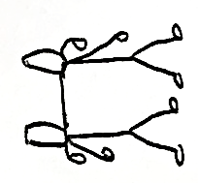  Get involved with a community project, charity work, or simply help someone you know. Doing useful things for others will help you feel better too. |   Relax  Make time for yourself. Allow yourself to chill out and relax. Find something that suits you! Breathe; imagine a balloon in your belly, inflating and deflating as you breathe in and out.
  Eat Healthily  Eat regularly, eat breakfast, eat healthily, eat fruit and vegetables, and drink water. | 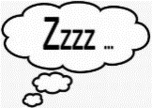  Balance Sleep  Get into a healthy sleep routine – including going to bed and getting up at the same time each day.
Connect with Others  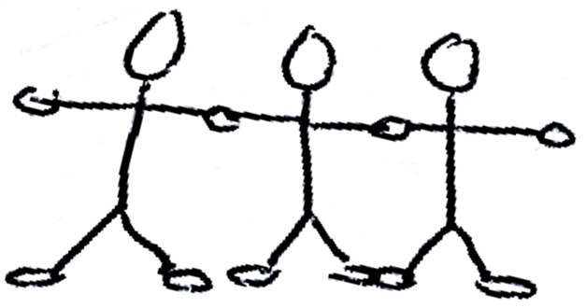  Stay in touch with family and friends – make contact regular and frequent. | Beware Drink and Drugs  Avoid using alcohol (or non-prescribed drugs) to help you cope – it will only add to your problems.
See the Bigger Picture  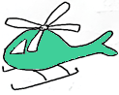  Take the time to broaden your perspective and consider the bigger picture (“the helicopter view”). Consider: What meaning am I giving this? Is this fact or opinion? How would others see it? Is there another way of looking at this? How important is it, or will it be in a year’s time? What can I do right now that will help most? | Accepting: ‘It is as it is’    We tend to fight against distressing thoughts and feelings, but we can learn to just notice them and give up that struggle. Some situations we just can’t change. We can surf those waves rather than try to stop them. Allow those thoughts and sensations just to be – they will pass.
These questions help you to think about positive qualities about yourself which can help to boost your confidence and self-esteem.
Some of these questions may be difficult, but if you struggle try to think about what a family member or friend would say?

- What strengths or positive qualities do you have? Even if some of the time, not all of the time…
…………………………………………………………………………………………………………………………
…………………………………………………………………………………………………………………………
…………………………………………………………………………………………………………………………
…………………………………………………………………………………………………………………………

- What have you achieved in your life? However small.
…………………………………………………………………………………………………………………………
…………………………………………………………………………………………………………………………
…………………………………………………………………………………………………………………………
…………………………………………………………………………………………………………………………

- What challenges have you faced? And overcome…
…………………………………………………………………………………………………………………………
…………………………………………………………………………………………………………………………
…………………………………………………………………………………………………………………………
…………………………………………………………………………………………………………………………

- What talents or skills do you have? However small…
…………………………………………………………………………………………………………………………
…………………………………………………………………………………………………………………………
…………………………………………………………………………………………………………………………
…………………………………………………………………………………………………………………………
…………………………………………………………………………………………………………………………

- What do others like or value about you? Skills, qualities, behaviour.
…………………………………………………………………………………………………………………………
…………………………………………………………………………………………………………………………
…………………………………………………………………………………………………………………………
…………………………………………………………………………………………………………………………

- Can you write down or say aloud 3 things you are grateful for in your life? These can be small things such as the cup of tea you had today or bigger things such as a family member or friend.

1.……………………………………………………………………………………………………………….
……………………………………………………………………………………………………………………….
2.……………………………………………………………………………………………………………………….
……………………………………………………………………………………………………………………….
3.…………………………………………………………………………………………………………………….
……………………………………………………………………………………………………………………….

- Sleep
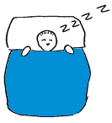
Sleep is as important to our health as eating, drinking and breathing. It helps our bodies to repair themselves and consolidates our memories and information processing.
Poor sleep can weaken immune systems and impact mental health difficulties like anxiety and depression.
Top Sleep Tips: What can you do?
- Go to bed at the same time every night and get up at the same
time every morning – this helps our bodies sleep cycles get in
sync! Don’t be tempted to sleep in more than an hour, even at the weekend.

- Eat well - plenty of dairy foods and dark green leafy vegetables, but avoid heavy meals before bed. Try drinking a cup of camomile tea before bed.

- Exercise - exercise daily but avoid strenuous activity 2 hours
before going to bed.

- Sleep in a comfortable environment – adjust the noise so it is quiet enough (try using ear plugs) and temperature of the room (try using fans to keep the room cool) and make sure it is dark (try using an eye mask). You could play soothing music that shuts off automatically after a while or use ear plug if you prefer silence.

- Only use your bed for sleeping – if you just use your bed for sleeping then you learn to associate your bed with sleep. Doing other activities in bed such as using your phone or watching TV, just makes you more awake.

- Take a warm shower or bath before bed – this may help you
to relax and make it easier to sleep.

- Place a drop of lavender oil on your pillow – this may help
you to feel relaxed which will help you to sleep.



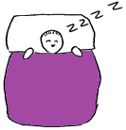
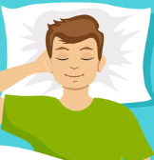

Top Sleep Tips: What should you avoid?

- Avoid caffeine (tea & coffee), nicotine (smoking) or alcohol –
even if used earlier in the day they can affect the quality of your
sleep and your ability to fall asleep. Caffeine can stay in your body
for up to 12 hours. Decaf also contains caffeine.

- Avoid napping – naps that are later in the day or over an
hour long will make it harder to sleep at night.

- Don’t force yourself to sleep – if you are not able to fall
asleep after 20 minutes, then get up and do a calming
activity such as reading, writing in a diary or drawing.

- Avoid phone, TV and computer screens – the blue light given off by
these tricks your body into thinking it is the morning and makes you
feel more awake. It affects your sleep cycle by delaying the release of melatonin which the body needs to release more of to help you fall
asleep.

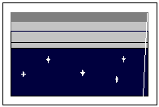


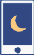

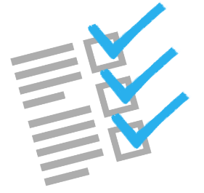
Pick 1 or more of these tips to start with and start trying to make them a part of your sleep routine.

You can use this as a checklist to tick off the tips you have started to use. Try to build up the number of tips you try over time.
Try listening to Jason Stephenson’s sleep meditation clips on YouTube.
Remember:
You need to regularly do these things for them to be most effective and everyone is different, so try and experiment to see what works for you.

- Eating

It may seem basic, but regularly eating a healthy balanced diet has many benefits which are essential to helping us maintain good mental health.
Benefits of a Healthy Diet
Physical Benefits
- Protects the body against diseases such as heart disease and type 2 diabetes.
- Improved blood pressure levels.
- Stronger immune system.
- Maintained energy levels throughout the day.
- Improved sleep patterns.
- Weight control.

Mental Benefits
- Increases energy levels.
- Promotes positive moods.
- Helps you to think clearly.
- Reduces depression.
- Improves learning ability.
- Builds self-esteem.

Tips to having a Healthier Diet
- Eat 3 meals a day and eat when you’re hungry and stop when you are satisfied/ full.
- Consume gut-beneficial foods and drinks like: raspberries, grapes, blueberries, broccoli, green peas, lentils, beans, whole grains, almonds, green tea & yoghurt.

What is a Healthy Balanced Diet?
This Eatwell Guide shows the main food groups which make up a healthy diet:
- Potatoes, bread, rice, pasta and other starchy carbohydrates
- Fruit and vegetables
- Dairy and alternatives
- Beans, pulses, fish, eggs, meat and other protein
- Oils and spreads
- Drink 6-8 cups / glasses of fluid each day
- Consume foods high in fat, sugar and salt less frequently and in smaller amounts. The guide shows an overall balanced diet over the day or week.
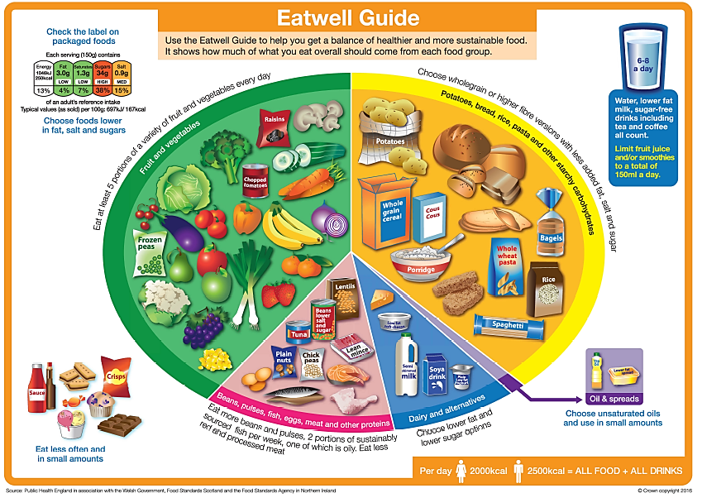

You can start with setting a goal around your eating habits such as trying to eat up to 3 meals a day! – 3 meals per day are recommended, but if that seems too difficult you can start with trying to eat 2 meals a day.
Making any sort of change is always difficult to start with but the more you do it (and keep doing it) the easier it will become!
The first step may be to plan your meals for the week and create a shopping list so you have everything you need.
Shopping List
Day of the week | Meals | Ingredients needed
Monday
Tuesday
Wednesday
Thursday
Friday
Saturday
Sunday
Try using a reminder chart like the one below to track the meals you have each day.
If you put this somewhere noticeable it can help you remember to eat. It should allow you to see the progress you make and hopefully motivate you to improve!

Week 1
Put a tick in each column when you have had a meal.
Write the day below | Breakfast | Lunch | Dinner
Day 1

Day 2

Day 3

Day 4

Day 5

Day 6

Day 7

Try to tell yourself well done each time you put a tick in the chart.
- Contact details

Contact numbers
Please see our self-help leaflet for contact numbers for the variety of available services in the area.

Duty Telephone Line
If at any point during your involvement with the Wellbeing Service you are struggling and feel that you need to talk with someone, you can access a duty worker by calling the team on 0121 543 4292 between the hours of 9 and 5, Monday to Friday. The duty worker can listen to you and support you.
Please note: this line is not for specific support related to this therapy workbook.

Recovery College
You can enrol onto courses via the Recovery College; they offer a range of courses on various topics such as mental health, employability and various arts. They also have volunteering opportunities.
Find out more on their website: https://www.therecoverycollege.co.uk/
Or call: 0121 543 406
Remember

You are in control of your recovery, and with support and guidance you can get to where you want to be.
Additional Resources
We encourage you to use the tables and charts we have provided for you but also ask that you try to create your own. These resources don’t need to be fancy and if you wish you can directly copy our versions or create a version suited more to you.
Throughout we have provided reminders of various resources that you may find useful in your recovery journey, so take a look at these and feel free to source similar resources for yourself.

References
The Window of Tolerance
- https://www.attachment-and-trauma-treatment-centre-for-healing.com/blogs/understanding-and-working-with-the-window-of-tolerance
- https://www.nicabm.com/trauma-how-to-help-your-clients-understand-their-window-of-tolerance/
Getting Moving and Activity
- Kamaldip Kahlwan- Older Adult Enhanced CMHT
Deep Breathing
- https://www.therapistaid.com/worksheets/deep-breathing-worksheet.pdf
Mindfulness
- https://www.therapistaid.com/therapy-worksheet/what-is-mindfulness
Positive Steps to Wellbeing
- https://www.getselfhelp.co.uk/docs/Steps%20to%20Wellbeing.pdf
Positive Emotions can be Difficult
- Training Our Minds in, with and for Compassion. An Introduction to Concepts and Compassion-Focused Exercises. Written by Paul Gilbert (2010).
Sleep Hygiene
- https://www.therapistaid.com/therapy-worksheet/sleep-hygiene-handout
Eating
- https://www.gov.uk/government/publications/the-eatwell-guide

