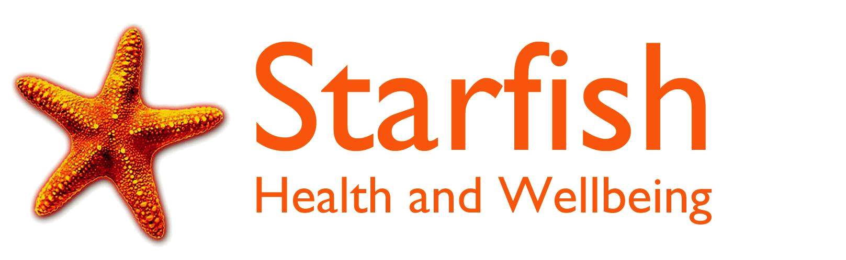
WOLVERHAMPTON SOCIAL HUB
Newhampton Arts Centre
Dunkley Street
Wolverhampton
WV1 4AN

Mobile: 07949290036
Landline: 01902 771776

Email: info@thesocialhub.org.uk
Website: www.thesocialhub.org.uk

- We are currently running a mixture of groups, both online and in person, at various locations around the City. Locations and addresses can be found in the pink box on the attached timetable.
- There is at least one group per day that is face to face, and you are welcome to attend as many as you would like.

Bilston – Drop In
Monday 9.30-11.30am
Weekly, to drop in and have a coffee and a chat!

Wednesfield Community Centre – Drop In
Monday 1.30-3pm
Weekly, to drop in and have a coffee and a chat!

Mindful Meditation (Zoom)
Tuesday 9:30-10:30am
This is a weekly, ongoing space to relax and take time for you. A guided meditation and soothing sounds.

Out and About Group (Various Locations)
Tuesday 10-12pm
Join us in exploring various locations and venues across the City – a great way to find new favourite spots, and meet new people.

Self-Care Workshop
Tuesday 12-1pm
A four-week structured course on why self-care is important, and how to do more of it!

Creative Writing (Zoom)
Tuesday 2.30-3.30pm
Join our friendly, ongoing weekly writing circle- no experience required! We work with prompts to get creative and unleash our inner writer!

LGBTQ+/Proud Parents Support Group (Zoom)
Tuesday 4-5pm
On alternate weeks, meet with like-minded people and receive support from the LGBTQ+ community and their allies.

Evening Social and Meditation (Zoom)
Tuesday 6-7pm
A weekly evening group to chat with other members and make new friends, and wind down with an evening meditation.

Volunteer Peer Support Meeting Drop in (Zoom)
Wednesday 10-11am
A fortnightly group for our volunteers to offer each other support, chat about ideas, or talk through concerns with the staff.

Lea Road Church – Joint Community Drop In (with Together in Penn Fields)
Wednesday 12-2pm
A weekly drop in, to make new friends and have a cup of tea or coffee.

Creative Coffee Shop Club (Face to Face)
Wednesday 2.30-4pm
Come along and have a hot drink and a chat, whilst we work with prompts to get creative and unleash our inner writer!

Mindful Meditation (Face to Face)
Thursday 10.30-11.30am
This is a weekly, ongoing space to relax and take time for you. A guided meditation and soothing sounds.

Variety Club (Face to Face)
Thursday 11.30am-12.30pm
A different activity each week but may include watching a film together, playing bingo, doing a quiz, doing jigsaws or playing games.

Craft and Chat (Face to Face)
Thursday 12.30-1.30pm
A relaxed, informal social group with crafting and conversation!

Weekly Quiz (Face to Face)
Thursday 1.30-2.30pm
Test your general knowledge in our just-for-fun weekly quiz – you might be amazed at what you know!

Structured Group – Mind and Body (Face to Face)
Thursday 2.30-3.30pm
A 4-week structured course on mental and physical health, and how they interact with each other.

Afternoon Tea and Chat (Zoom)
Thursday 3.30-4.30pm
A weekly zoom drop-in session and a great chance to meet new people.

Crafting Friday (Face to Face)
Friday 9.30-11.30am
A relaxed, informal social group with crafting and conversation!

Drama (Zoom)
Friday 10.30-11.30am
A fun, informal weekly Drama group- no experience required!

The Confidence Community (Zoom)
Friday 1-2pm
A 4 weekly course to develop a community and activity-based approach to building confidence.

Film and Book Club (Zoom)
Friday 4-5pm
A volunteer led group, giving members the opportunity to talk about books and films, and pass on recommendations.

